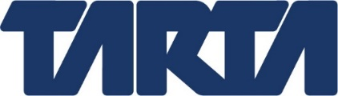

TOLEDO AREA REGIONAL TRANSIT AUTHORITY
GOVERNANCE COMMITTEE MEETING
September 16, 2021
4:00 p.m.
TARTA
1127 West Central Avenue

AGENDA

- Call to order

- Roll call

- Determine whether to enter executive session to consider the appointment and/or employment of public employees and public employee compensation

- Return to regular session

- Adjourn

